

# Submitted To

Dr. Ahmed Wasif Reza

Ph.D., M.Eng.Sc., B.Sc. Engg (Hons.), CEng (UK)

Associate Professor  
 Department of Computer Science & Engineering

# Title

Hungry Snake

# Submitted By

G M Mahmudul Hasan

(2016-2-60-063)

Nahid Hossain

(2016-2-60-136)

Tanha Tanjimat

(2016-2-60-058)

Noor-E-Zannat Anni

(2016-2-60-057)

# Date of Submission

08-12-2016

**Assignment Mark Sheet**

|  |  |  |
| --- | --- | --- |
|  | **Max** | **Awarded** |
| **A. Report** |  |  |
| i. Introduction / Problem statement |  |  |
| iv. System Design |  |  |
| v. Screen shots |  |  |
| vi. Source code |  |  |
| vii. Disk/CD neatly attached (Y/N) |  |  |
|  |  |  |
| **B. Source Code** |  |  |
| i. Style |  |  |
| Indentation |  |  |
| Self documentation |  |  |
| ii. Modularity (small size functions) |  |  |
| iii. Error reporting capabilities |  |  |
| iv. Code efficiency and strategy |  |  |
|  |  |  |
| **C. Program execution** |  |  |
| i. Compile without errors |  |  |
| ii. User friendly |  |  |
| iii. Error free during runtime |  |  |
| iv. Program output |  |  |
|  |  |  |
| **D. Presentation and Demonstration** |  |  |
| i. Presentation and communication skills |  |  |
|  |  |  |
| **E. Bonus** |  |  |
| i. Extra significant features |  |  |
| **TOTAL** |  |  |

**Assignment Declaration**

## (Student 1)

|  |  |
| --- | --- |
| **ID** | 2016-2-60-063 |
| **Name** | G M Mahmudul Hasan |
| **Session** | Fall-2016 |
| **Assignment No.** | 01 |
| **Date submitted** | 08-12-2016 |
| **Deadline of the Assignment** | 08-12-2016 |
| **My contribution in doing this**  **assignment (in percentage) in the group** | 25% |
| **Description of my contribution in this assignment in the group** | Some certain functions to run this program  properly |
| **Number of hours I spent in doing this assignment** | More than 12 hours |

## (Student 2)

|  |  |
| --- | --- |
| **ID** | 2016-2-60-136 |
| **Name** | Nahid Hossain |
| **Session** | Fall-2016 |
| **Assignment No.** | 01 |
| **Date submitted** | 08-12-2016 |
| **Deadline of the Assignment** | 08-12-2016 |
| **My contribution in doing this**  **assignment (in percentage) in the group** | Some certain functions to run this program  properly |
| **Description of my contribution in this assignment in the group** | 25% |
| **Number of hours I spent in doing this assignment** | More than 12 hours |

## (Student 3)

|  |  |
| --- | --- |
| **ID** | 2016-2-60-058 |
| **Name** | Tanha Tanjimat |
| **Session** | Fall-16 |
| **Assignment No.** | 01 |
| **Date submitted** | 08-12-16 |
| **Deadline of the Assignment** | 08-12-16 |
| **My contribution in doing this**  **assignment (in percentage) in the group** | Main function |
| **Description of my contribution in this assignment in the group** | 25% |
| **Number of hours I spent in doing this assignment** | More than 8 hours |

## (Student 4)

|  |  |
| --- | --- |
| **ID** | 2016-2-60-057 |
| **Name** | Noor-E-Zannat Anni |
| **Session** | Fall-16 |
| **Assignment No.** | 01 |
| **Date submitted** | 08-12-16 |
| **Deadline of the Assignment** | 08-12-16 |
| **My contribution in doing this**  **assignment (in percentage) in the group** | 25% |
| **Description of my contribution in this assignment in the group** | Main function |
| **Number of hours I spent in doing this assignment** | More than 8 hours |

**We hereby certify that this assignment represents the work done by all our group members with our contribution clearly stated above without copying from any other resources. We declare that no part of our work has been copied from or by other groups, and that no collusion has taken place with any other persons or groups.**

**We certify that any disks submitted with this assignment have been virus checked and have no viruses on them.**

(1) Signature: …………………………… Date: ........................................

(2) Signature: …………………………… Date: ........................................

(3) Signature: …………………………… Date: ........................................

(4) Signature: …………………………… Date: ........................................

**Introduction**

We, the students of East West University of CSE department have developed a project/game named “Hungry Snake” under the custody of Dr. Wasif Reza sir in the course of CSE107.We have a team of four members and the list is given in the cover page. The game is a very simple as a snake or figure finds a block compared as its food. When it finds the block 10 point will be added to the score of user. The user can move the snake by using the up/down/right/left wherever he/she wants. But when the snake hits the border or the wall of the screen the game becomes over as it has been found as a wrong movement of user. Besides, by eating the foods snake become larger than before. So, when the snake faces or clashes its own body the game becomes finished as well. There are three different difficulty level in this games those are easy, medium and hard by the aspects of speed of snake. By increasing level speed of snake goes up for the sake of difficulty.

We tried to make this game without any narrowness but for shortage of time and our ignorance the game has some limitations. However, we four people have worked together and believed in ourselves.

To conclude, we are grateful to Allah since we have finished our program so well and thanks to our teacher Dr Wasif Reza for give us the opportunity and help us as much as he can….

Happy snaking….

**Flow chart**

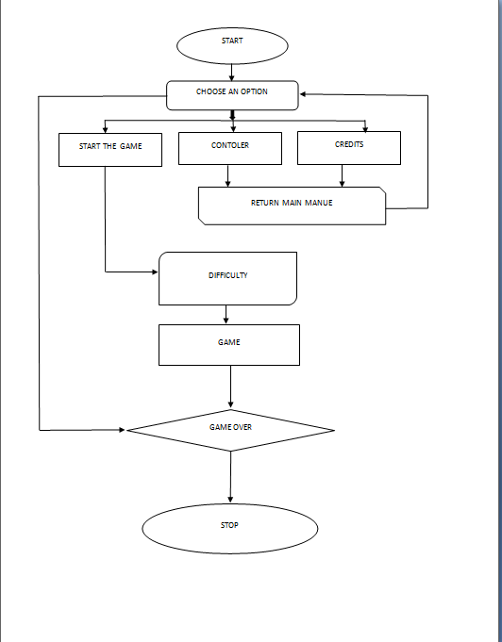

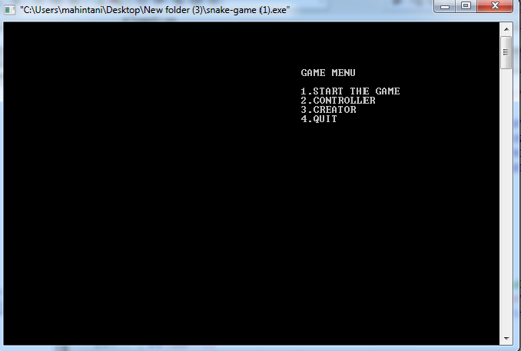

Fig1: Starting of the game

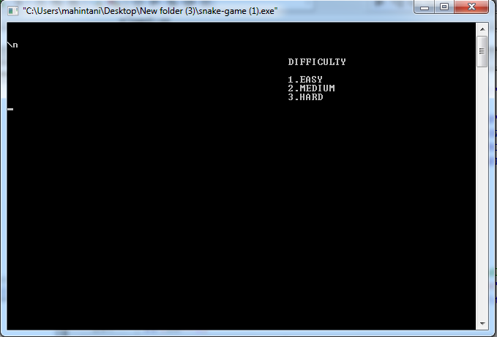

Fig2: Levels

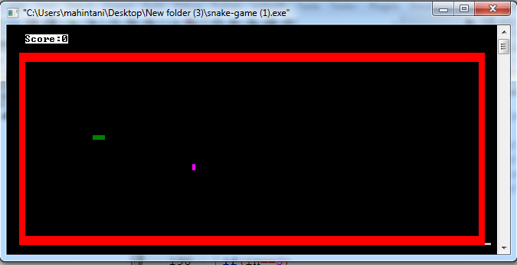

Fig3: Let’s play